
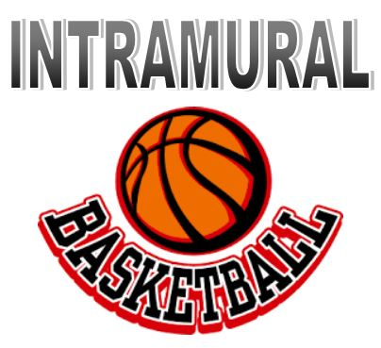

Men’s 1st Session

Sign up your ‘TEAM’ up before Thursday October 1st by emailing rlawson@huntington.edu

- be sure to designate who is the team captain
- you certainly do NOT have to have playing experience to play
- games will be played on Sunday nights 8pm and 9pm
- Call your own fouls

Opening night is November 4th

Post season tournament is November 22nd

