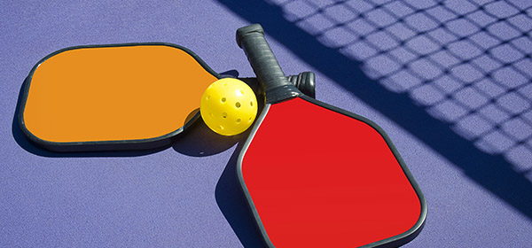

HUNTINGTON UNIVERSITY

Intramural Pickle Ball League

Sign you and your partner up before October 5th by emailing rlawson@huntington.edu

- be sure to designate a captain, maximum roster size is 3 players
- you certainly do NOT have to have playing experience to join
- games are on Thursday nights at 7pm, 8pm, and 9pm at the PLEX
- Best of 3 games with rally scoring to 21

Opening night is Oct. 8

Post season tournament will be November 19th

